Exponents  Handout-Answers | Name:  Date:
Objective: Simplifying Exponential Expressions Using the Properties of Exponents
Segment 1: Definition of an Exponential Expression

Given a real number a and n natural number, we define
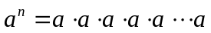
n factors
In the expression 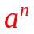the number a is the base, and n is the exponent or power to which the base is raised.

Segment 2: Simplifying Exponential Expressions Using the Product Property of Exponents
Product Property of Exponents
If x is any real number and m and n are natural numbers, then

When multiplying exponential expressions with the same base, retain the common base and add the exponents. Use this sum as the exponent of the common base.

Example 1 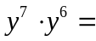 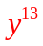
Example 2 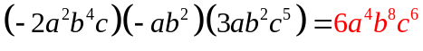
Segment 3: Simplifying Exponential Expression Using the Power Property of Exponents
Power Property for Powers of Exponential Expressions
If x is any real number and m and n are natural numbers, then

When an exponential expression is raised to a power, retain the base and multiply the exponents. Place the product of the exponents on the base and remove the parentheses.

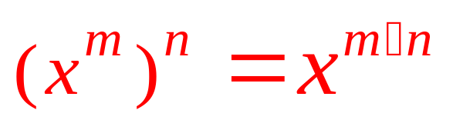

Example 3 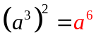
Example 4 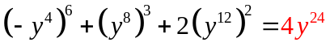
Power Property for Powers of Products
If x and y are any real numbers m is a natural number, then

When a product is raised to a power, then each factor in the product is raised to that power.
Warning: 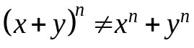 (When a sum is raised to a power, the definition of an exponent and polynomial multiplication must be used.)

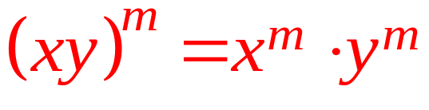

Example 5 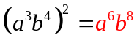
Example 6 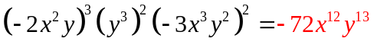

Practice 1 The expression 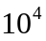is written in ____exponential____form, where 10 is the ___base____ and 4 is the ___exponent____.

Practice 2 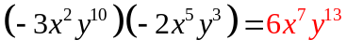

Practice 3 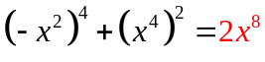

Practice 4 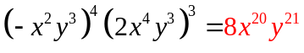

Segment 4: Simplifying Exponential Expression Using the Quotient Property of Exponents
Quotient Property of Exponents
If x is any nonzero real number and m and n are natural numbers, then

When dividing exponential expressions with the same nonzero base, retain the common base and subtract the exponent in the denominator from the exponent in the numerator. Use this difference as the exponent of the common base.

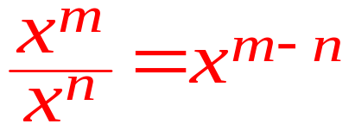

Example 7 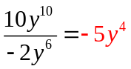

Example 8 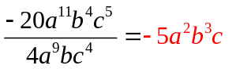
Power Property for Powers of Quotients
If x and y are any real numbers, such that 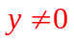 and m is a natural number, then

When a quotient is raised to a power, then both the numerator and denominator are raised to that power.

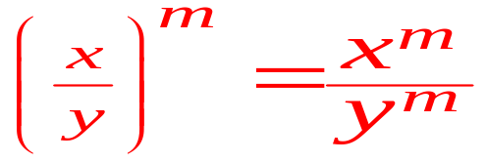

Example 10 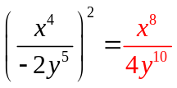

Example 11 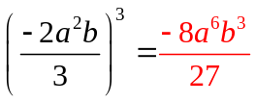
egment 5: Simplifying/Evaluating Exponential Expression Using the Definitions of Zero and Negative Exponents

Definition of a Negative Exponent
If x and y are any nonzero real numbers and n is any natural number, then

Definition of a Zero Exponent
If x is any nonzero real number,

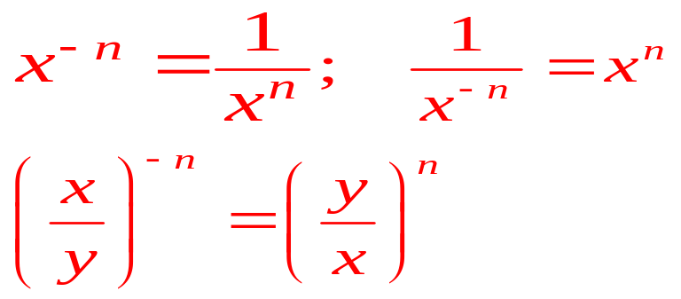
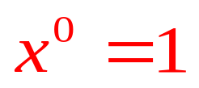

Example 12 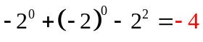
Example 13 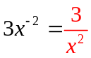
Example 14 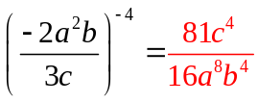

Example 15 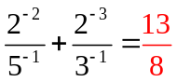

Segment 6: Simplifying Exponential Expression Using More Than One Property of Exponents

Example 16 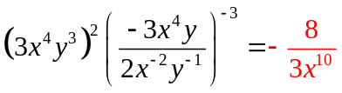
Example 17 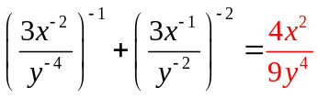
Practice 5 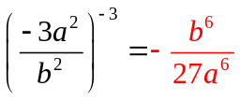

Practice 6 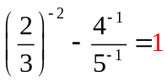

Practice 7 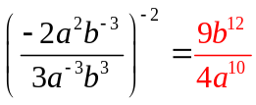

Practice 8 